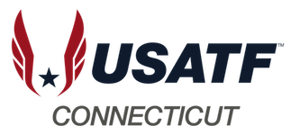

USATF -CT T&F MASTERS!

Ready to compete?

USATF-CT has partnered with CSMG for a Masters/Open meet on May 31, 2025.

All events will be contested except for the hammer.

Check out the CSMG website for more information and registration: [www.csmg.org](http://www.csmg.org)

***COME OUT AND PLAY!!!***